I.E. MANUEL J. BETANCUR
Formamos para la vida, la ciencia y la cultura

VERBO MODAL CAN WORKSHOP (II)

Name: ___________________________________________________ Group: _______

Escribe una (1) respuesta con base en el ejemplo. .

Ejemplo:

Can you fly a kite? (¿Puede usted volar una cometa?)
Yes, I can fly a kite (Opción 1)
No, I can not fly a kite (Opción 2)

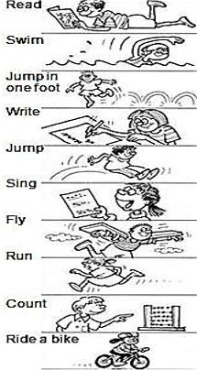

- Can you read a book in English?
_____________________________________

- Can you swim in a pool?
_____________________________________

- Can you jump in one foot?
_____________________________________

- Can you write fastly?
_____________________________________

- Can you jump on the bed?
_____________________________________

- Can you sing rap music?
_____________________________________

- Can you fly by yourself?
_____________________________________

- Can you run with barefeet?
_____________________________________

- Can you count with an abacus?
_____________________________________

- Can you ride a bike?
_____________________________________

